TASK 3 Shri raksha

1. Top Student Per Course
SELECT
c.CourseName,
s.Name AS StudentName,
e.Grade
FROM Enrollments e
JOIN Students s ON e.StudentID = s.StudentID
JOIN Courses c ON e.CourseID = c.CourseID
WHERE (e.CourseID, e.Grade) IN (
SELECT CourseID, MAX(Grade)
FROM Enrollments
GROUP BY CourseID
);

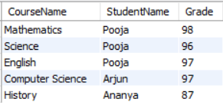

2. Pass Rate Per Course (Grade ≥ 40)
SELECT
c.CourseName,
ROUND(
SUM(CASE WHEN e.Grade >= 40 THEN 1 ELSE 0 END) * 100.0 / COUNT(*),2 ) AS PassRate
FROM Enrollments e
JOIN Courses c ON e.CourseID = c.CourseID
GROUP BY c.CourseName;

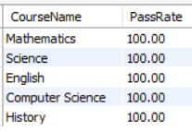

3. Overall Topper Across All Courses
SELECT
s.Name AS StudentName,
SUM(e.Grade) AS TotalMarks
FROM Enrollments e
JOIN Students s ON e.StudentID = s.StudentID
GROUP BY s.StudentID, s.Name
ORDER BY TotalMarks DESC
LIMIT 1;
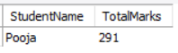

4. Students Enrolled in Multiple Courses
SELECT
s.Name AS StudentName,
COUNT(e.CourseID) AS TotalCourses
FROM Enrollments e
JOIN Students s ON e.StudentID = s.StudentID
GROUP BY s.StudentID, s.Name
HAVING COUNT(e.CourseID) > 1;
